

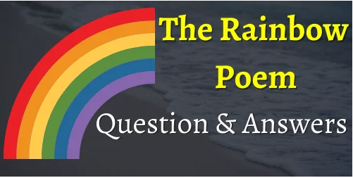

**I.Answer the following question in complete sentences:**

**(a) What is prettier than boats, ship and clouds?**

Answer – A rainbow is prettier than boats, ships and clouds.

**(b) What are the clouds compared to?**

Answer – Ships and boats are compared to the clouds.

**(c) How do you think the rainbow builds a road from the earth on the sky?**

Answer – I think the rainbow builds a road from the earth to the sky, because it overtops the trees.

**(d) Which, according to the poet, is the prettiest of all objects mentioned in the poem?**

Answer – According to the poet, the rainbow is the prettiest of all objects mentioned in the poem.

<https://www.youtube.com/watch?v=bcfLBpB4GSE> Link The Rainbow